CARD 1

Llanymynech Limeworks Heritage Area

Suggested Route For Key Stage Two Children
The following tour is intended to introduce children to the Heritage Area, starting with the rock face, leading on to look at evidence of quarrying and limestone burning, studying the methods of transporting the stone and quicklime then culminating in a tour of the Hoffmann Kiln. An emphasis is placed upon the difficult working conditions, the hardships of this way of life and the particular dangers involved. It is the route taken by tutors and guides, but it can equally well be used by teachers working independently. The paths can best be seen on the Heritage Area Map.
In addition to the route, a suggested commentary is included. This is the commentary that would be used by a guide or tutor booked to take classes around the area and involves guides adopting the role of three characters from the period around 1900: John Roberts, a foreman, Harry a Limestone Packer and Mr. Evans, a Government Inspector. Teachers could similarly follow this way of teaching in role if they wished.

Stopping Points
1) The English Quarry
2) The Draw Kiln
3) The Drum House
4) Viewpoint over the Severn Vyrnwy Plain
5) The Welsh Quarry
6) The Powder House
7) The Tramway Tunnels under the A483
8) The Tally House
9) The Stables
10) The Draw Kilns
11) Viewpoint above the Hoffmann Kiln
12) Inside the empty chamber of the Hoffmann Kiln
13) By the limestone walls inside the Hoffmann Kiln
Please note:
Although the area around the Hoffmann Kiln is suitable for children using wheelchairs, other paths near the quarries are not. Teachers working without a guide should walk the route first before leading groups of children.
It is recommended that teachers carry first aid kits and mobile phones.
Toilets and hand washing facilities are only available inside the Stables Education Block. If this building has not been booked, it is unlikely to be open.
CARD 2

Directions and Suggested Commentary

Setting
Children adopt the role of young people looking for jobs in 1900. It is Saturday afternoon, when the works would have been closed. The guide or teacher puts on a cap and scarf and adopts the role of John Roberts, the limeworks company foreman who shows them around the site, asking questions to see how alert they are. The guide should include the key ideas at each point of the route – an example of how this might be done is given for the start of the walk and for Point 1.

John Roberts
So, you’re hoping for jobs in the Limeworks are you? Well, we do need plenty of young fit people to work in the new Hoffmann Kiln, but before we look at that, I want to take you for a walk to see where the limestone comes from. We’ll walk up the route of the tramway – that’s a small railway that carries trucks – you will be able to see one of our trucks in the cutting. You can have a go at pushing it later on and we’ll see how strong you are!
From the Stables, walk across the path and look at the truck on the tramway rails in the cutting. Then turn left and walk up the path, under the A483 and continue up the English Inclined Plane until you reach the quarry face. Turn right, making your first stop overlooking the steep wall of the English Quarry.

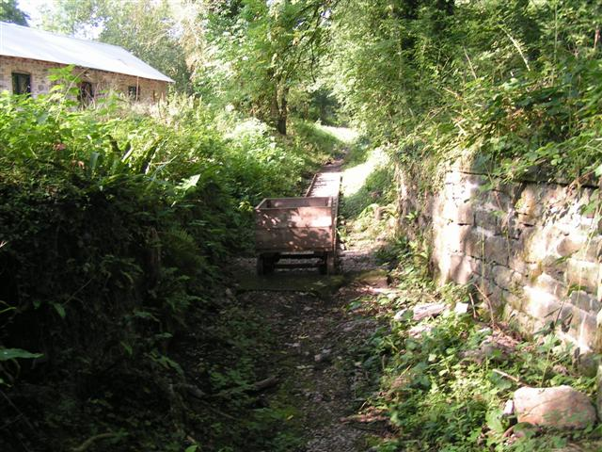

CARD 3

Point 1 – The English Quarry

John Roberts:
So, here we are at the rock face. You’ve all seen this cliff before from the village. Who can tell me, is it natural or man-made? The rock was made millions of years ago when this area was at the bottom of a shallow sea. The remains of sea shells settled at the bottom of the sea and gradually turned into rock we call limestone. The remains of their shells can still be seen sometimes – we call them fossils. Can anyone see where the rock has been broken from the cliff face?
How do you think we break the rocks off the cliff? Have a look at those vertical grooves. We drill holes in the rock face, fill them with blasting powder, then the blasting takes place, usually last thing of an evening. When the powder explodes, we cover our ears and the air is full of dust. We come back the next morning to start breaking the rock and taking it away in the trucks. What do you think we use the rock for?

Turn off the path to the right to reach the Draw Kiln

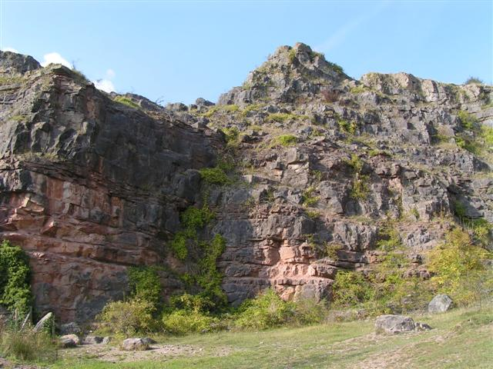
CARD 4

Point 2 – The Draw Kiln
- This kiln is obsolete in 1900 and has been fenced off to prevent accidents
- Limestone and coal were loaded into the top of the kiln, then set alight.
- A strong draught of air came into the base of the kiln which became extremely hot.
- The heat changed the limestone into quicklime.
- Quicklime still looks like limestone but it is lighter.
- Quicklime can burn your skin if it is wet, as it reacts with water producing heat.
- The quicklime used to be shovelled out of the bottom of the kiln and loaded onto trucks.
- It was spread on the fields to improve the soil or used to make lime mortar for building.

Return to the main path and retrace your steps until you reach the English Drum House

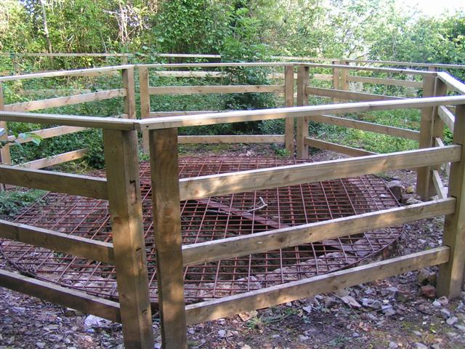
CARD 5

Point 3 – The English Drum House
- This is where the limestone is sent down the hill.
- How do you think we get the rock down the hill?
- Ask what they think this drum is used for? (They will find out later)
- Tell them to look out for the tunnel on the right-hand side bringing a tramway from the Welsh Quarry.
Walk up the path and through the kissing gate into Wales. Stop by the disused Welsh Drum house to gather the group together, perhaps asking for other suggestions as to how it worked, then continue to the viewpoint, keeping children well away from the edge. Explain they are now in Wales.

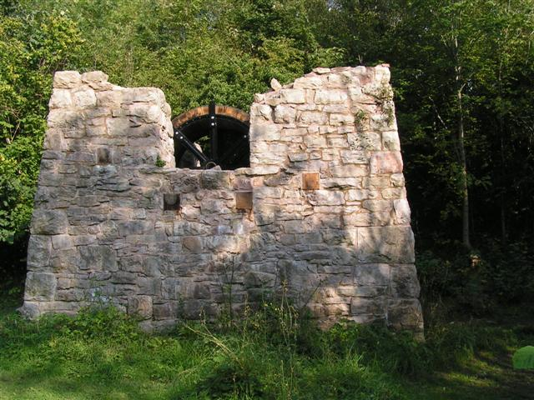
CARD 6

Point 4 – Viewpoint over Llanymynech and the Severn Vyrnwy Plain
- Explain that this was a spoil heap where the poor-quality rock called raffle was dumped.
- Point Llanymynech village – the boundary between England and Wales passes through it!
- Ask about the difference between Llanymynech rocks and the Severn Vyrnwy Plain
– Ask which is better for railways and canals
- Point out the church clock, built big enough to be seen by the quarry men on the hill.
- Point out the directions of Wales, Shrewsbury and Telford.
- Look across the valley to Creiggion, an old volcano, where a granite quarry is still working.

Walk back to the main path and into the Welsh Quarry, stopping where you can see down the incline towards the tunnel.

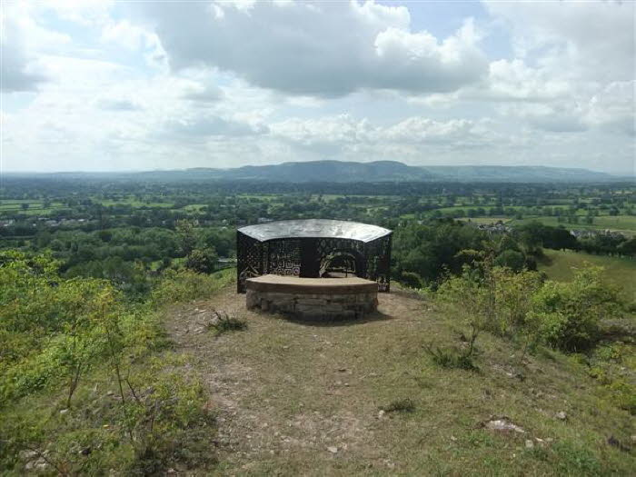
CARD 7

Point 5 – The Welsh Quarry
- Imagine the noise and dust when the explosives were detonated.
- Consider the dangers of working here and how hard the work must have been.
- Look down to the tunnel that took the tramway carrying trucks down the hill.

Continue through the Welsh Quarry until you reach the Powder House. Children will need to go inside in small groups.

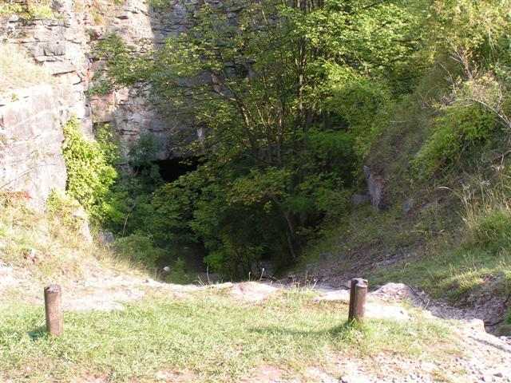
CARD 8

Point 6 – The Powder House
- Ask for suggestions – was it a cave or was it man made?
- It may have been a store for gunpowder, detonators or tools.
- It might have been used as a shelter for the men having lunch.
- Maybe it was used for different purposes over the years.
Continue down the remains of the Welsh Inclined Plane until you reach the tunnels. Ask the children to look out for signs of past work such as grooves in the stones caused by chains, or bolt holes in the rocks that once held stone tramway sleepers. Warn them not to run as it is steep!

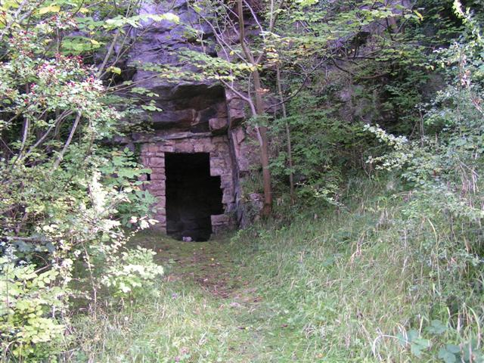
CARD 9

Point 7 – The Tunnels under the road
- The tramways went under the road
- There were two tunnels, one from the Welsh Quarry and one from the English Quarry.

Continue down the path to the Tally House

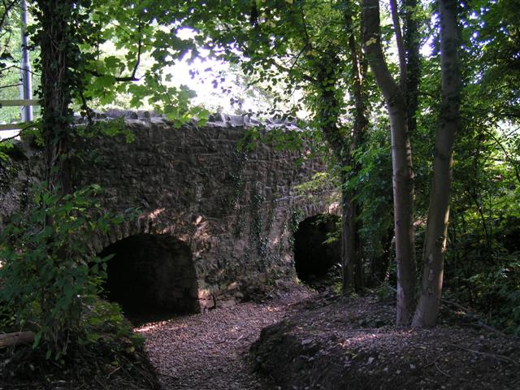
CARD 10

Point 8 – The Tally House
- The Tally Man weighed and recorded how much rock each team had quarried
- Men were paid according to the weight of stone they produced.
- It was best to remain friends with the Tally Man!
- He then sent the trucks in different directions, to the kilns, the canal or the railway.

Return to the Stables Block

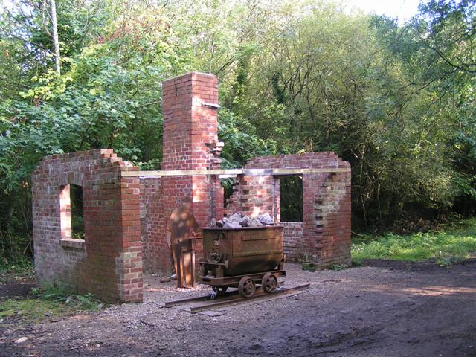
CARD 11

Point 9 – The Stables
This is where the mules, horses or donkeys were sheltered and fed
- They were used to pull the trucks
- There were 6 stalls each holding two animals, with a window for each stall.

Children can now use the Stables Block for a toilet stop and to eat their packed lunch. After lunch they can work in three groups, with adult supervision, to carry out the following tasks:

1) - Examine the model of an Inclined Plane, explaining how the Drum House worked
- Explain the model of the Hoffmann Kiln, especially the routes of the trucks
- The Hoffmann Kiln was a huge, modern (1900) building for burning limestone

2) Attempt the Artefact Quiz, identifying different artefacts labelled A – L

3) Try moving a tramway truck – see Risk Assessment
Following the lunchtime activities, adults can return to working in role. John Roberts, the foreman, leads the group back up the path to visit the Hoffmann Kiln.

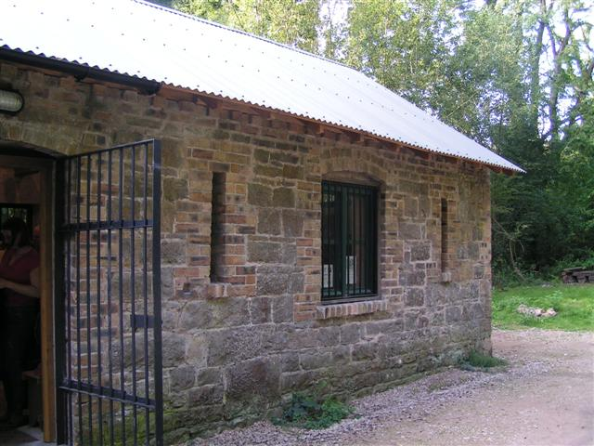
CARD 12
Following the lunchtime activities, adults can return to working in role. John Roberts, the foreman, leads the group along the track leading up from the stables. Ignore the turning to the right. Carry on up the track, past the site (foundations only) of the ‘office’ until you come to a path to your right through a gap (former bridge) in the large embankment on the right. Take this turning which will lead the tramway junction.

Point 10 – The Tramway Junction
John Roberts introduces this area as a busy junction where tramways lead to different destinations and a mainline siding is used by a steam locomotive pushing trucks to bring coal in. He stresses the importance of doing what you are told and learning the meaning of whistles and flags that are used to control the coming and going of trucks. (Use the interpretation board to help you picture the general layout).
- Looking uphill you can see various tramway cuttings and embankments allowing trucks full of stone to come from the Tally House and go to different destinations.
- to your left is a large embankment that is intersected by a gap – a former bridge. This tramway led to two large draw kilns. It carried limestone and coal. By 1900 it was mostly disused.
- centrally in front of you is a cutting allowing a tramway to carry stone to the Hoffmann Kiln.
- to your right is an embankment that stops abruptly – it has an old truck on it. This was a ‘wharf’ from which limestone could be tipped into mainline full-size railway trucks.

The English Canal Wharf

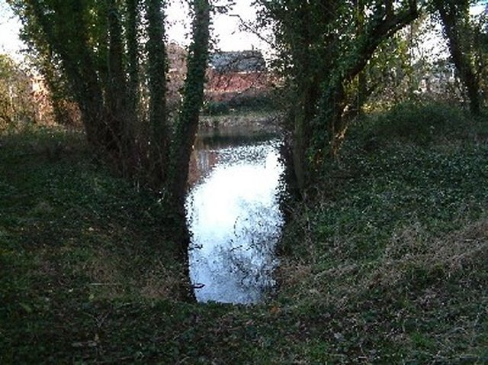
CARD 13

Point 10 continued
Downhill towards the Hoffmann Kiln
- Looking downhill you can see the various routes taken by the trucks:
- through the gap in the large embankment (through which you have just come) and on to the main track is the tramway that carried limestone to the canal or the railway.
- to your right is a large embankment that is intersected by a gap – a former bridge. This tramway led to two large draw kilns. It carried limestone and coal.
- along the central embankment a tramway carried coal to the Hoffmann Kiln. This coal had been unloaded from mainline railway trucks on to a ‘wharf’ on the left-hand edge of the embankment.
- diagonally left (to the left of the modern wire fence) is the route of the mainline railway siding that brought coal in and took stone out.
- along the right hand cutting to carry limestone to the wicket gates of the Hoffmann Kiln.

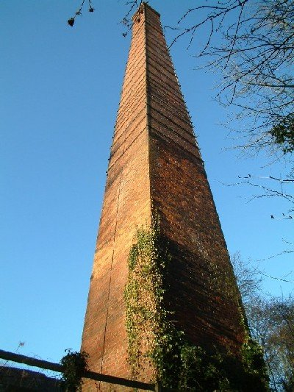

Now walk downhill to the viewpoint above the Hoffmann Kiln
CARD 14

Point 11 - View Point Above the Hoffmann Kiln
- In 1900 this was the latest technology, a kiln producing large quantities of quicklime
- Look for the routes of the coal trucks, coming up from the railway
- Point out the routes of the limestone trucks coming down the hill
- look at the doors (wickets) for the limestone to be taken inside the kiln
- Point out the tramways taking trucks full of quicklime away from the kiln
- Look for the stoke holes in the roof for loading in the coal
- Ask what the chimney was for - although it removed smoke, the main purpose was to encourage a draught of air to keep the kiln hot

Walk down the path to look at the kiln from the outside and then walk inside, near the truck containing limestone.

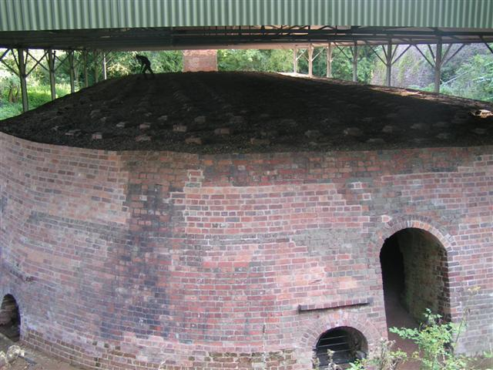
CARD 15

Point 12 – Inside the Kiln
- Explain it is unusual to be able to come in here as it is usually too hot and full of stone and coal, but for the last couple of weeks it has not been operating because improvements and repairs are being undertaken.
- Warn them to mind their heads on the low ceiling and not to pick up any stones as they may be quicklime which can irritate or burn the skin
- Explain that they can have a few minutes to look around, but when they hear a whistle blow, they must come back to this spot.
- Explain that when they return there will be a different character to meet them, wearing different clothes.

As leader, you may simply “change hats” or you may ask a different adult to adopt the role of Harry, a Limestone Packer in the Hoffman Kiln.

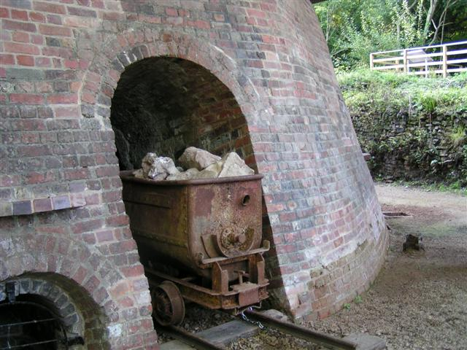
CARD 16

Point 13 – Inside the Hoffmann Kiln, by the limestone walls
Harry introduces himself and says that he has stayed on specially to explain to the new recruits what it is like to work in the Hoffmann Kiln. Harry will elicit questions about working conditions, how the kiln works, his pay and even his home and social life. Amongst other things he explains:
- Trucks of limestone come from the quarry, are turned on the turntable then pushed into the Kiln
- Harry is a Packer – firstly he empties the truck
- Next he builds a double limestone wall inside the kiln
- Then he bricks up the wicket door
- A Firer feeds coal through the stoke holes in the roof
- This fills up the space between the walls
- The fire in the kiln, which usually burns continually, is allowed to reach the coal.
- As the coal burns it changes the limestone into quicklime
- When the fire has passed that section, Lime Drawers open up the wicket door.
- The Lime Drawers shovel the quicklime onto trucks
- Men then push the trucks down to the railway line

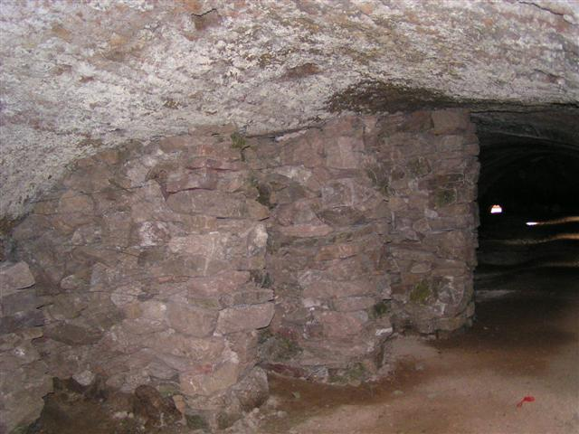

- Harry answers questions about what it is like to work there – consider heat, thirst, backbreaking work, smoke and dust, quicklime irritating the skin leaving pockmarks.
Before leaving the Hoffmann Kiln ‘platform’ turn to your right in front of the steps near the chimney and walk in front of the draw tunnels of two Draw Kilns. To see the second draw tunnel you will need to walk on to a steel platform.

CARD 17

Point 14 – Two Draw Kilns built in the 1870’s
- In 1900 this would have only recently closed. John Roberts explains that they could be reopened if the Hoffmann Kiln has to be closed for repairs or if the demand for quicklime exceeds the capability of the Hoffmann Kiln
- This was like the Draw Kiln seen at Point 2
- Behind the kilns a large embankment carried coal and limestone to the kiln
- The quicklime was drawn out at the bottom of these kilns and dropped from the platform in front on to full size trucks waiting on the mainline siding known as the ‘Rock Siding’

Finally, return to the steps near the Hoffmann Kiln chimney, go down the steps, turn right, walk along the track below the draw kilns (there is a board with a diagram showing how a draw kiln works here) and rejoin the main track leading to the stables

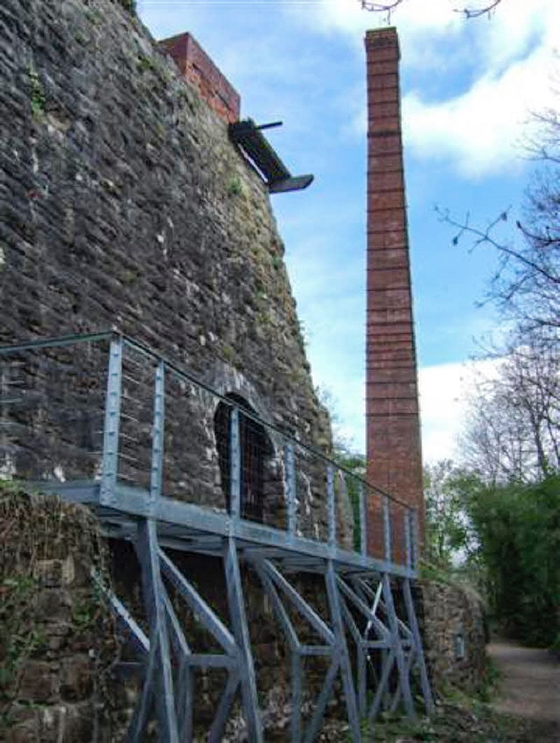
CARD 18

The Arrival Of A Government Inspector – 1905
After answering questions, either Harry needs to revert to the role of John Roberts, or John Roberts returns to the scene. He takes the group back to the stables. At the stables the group are asked to imagine that it is now 5 years later. They were all taken on as workers at the Llanymynech Limeworks and have worked there ever since. John Roberts tells them that an inspector is coming to look at the works. He warns them to be careful what they say because if they criticise the company it might close and they would lose their jobs.

Mr Evans – The Government Inspector
The inspector tells the group to ignore any threats that may have been made. They can talk to him in confidence and tell him what it is really like to work here. He asks them to respond to the following questions:

1) Which is the most dangerous job that men do at Llanymynech?

2) I have noticed that many of the Lime Drawers who remove the quicklime have marks on their faces and hands. Can you tell me what has caused these?

3) How old have boys got to be before they can be given a job at Llanymynech?

4) The quarry men grumble about their pay. Do you know how their pay is decided?

5) There have been a number of injuries over the years and some men have even been killed. Have any of you had personal experience of accidents, or do you know someone who has? Have you had any ‘near misses?’ Can you suggest ways to prevent injuries happening at Llanymynech?

This is the end of the guided tour. However, this activity leads on to the activity called “The Inspector’s Report,” which may be completed at school.

